**ENGS203P: Mathematical modelling and analysis II**

**Questions**

Topic 1: Series

1. Find the sum of all odd numbers between 0 and 100.

2. Evaluate the sum of the infinite series: 

3. The Maclaurin expansion for sin() provides a “small angle” approximation: $\sin{θ}≈θ$. What is the smallest positive angle at which this approximation gives an error of five percent? Express your answer to the nearest degree.

4. Use the Maclaurin expansion for cos(*x*) to find the first two non-zero terms of the Maclaurin expansion for cos2(*x*).

5. Use Maclaurin series to calculate the following integral to 3 significant figures:

6. A rectangular function is expressed mathematically as follows:

*f(x)* = 1 for -π/2 < *x* < π/2

*f(x)* = 0 for -π < *x* < -π/2 and π/2 < *x* < π

Which of the following descriptions of the Fourier series of *f(x)* are true:

A. The Fourier series contains no cosine functions.

B. The Fourier series contains no sine functions.

C. The Fourier series contains cosine and sine functions.

D. The Fourier series contains no cosine or sine functions.

Topic 2: Transforms

1. A graphical representation of the Fourier transform of the signal *s(t)* below will exhibit two peaks. Estimate the positions of these peaks on the frequency axis.

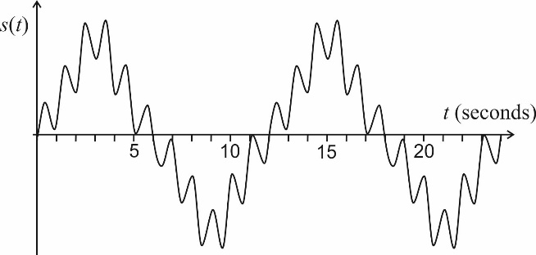

2. When a camera lens is defocussed, which of the following statements is false:

A. The image appears smoother.

B. The camera’s “point response function” becomes broader.

C. The spectrum of spatial frequencies contained within the image becomes broader.

D. Multiplying the Fourier transform of the image by a constant will not affect the smoothness of the image.

3. A machine emits a short pulse of sound, with constant intensity over a duration of 2 ms. Estimate the highest possible frequency emitted within the pulse.

4. Use a [table](https://en.wikipedia.org/wiki/Laplace_transform) of Laplace Transforms to find Γ[et cos 2t].

5. {Can this be converted into a suitable Quiz question?}

Use Laplace transforms to solve the following differential equation given that *y* = 1 and d*y*/d*t* = 3 at *t* = 0 :



**Answers**

Topic 1: Series

1. First term *a* = 1

Common difference *d* = 2

Number of terms *n* = 50

$Sum=\frac{n}{2}\left(2a+\left(n-1\right)d\right)$

⇒ *Sum* = 25(2 + 49x2) = 2500

2. This contains two geometric series with first term *a* = 1 and common ratios *r* of ½ and 1/3 respectively. Number of terms *n* = ∞.

$Sum=\frac{a(1-r^{n})}{1-r}$

⇒ *Sum* = [1 – (½)∞ ]/[1 – ½] - [1 – (1/3)∞ ]/[1 – 1/3] = ½

3. The error for  in radians is given by: [sin() – ]/sin() x 100%.

Using a calculator, the error is found to be 5% at  ≈ 0.552 radians or about 31. 6 degrees.

⇒ Smallest positive angle = 32 degrees.

4. The Maclaurin expansion for sin(*x*):

⇒

⇒

5.

⇒

⇒ = 1.44…

6. B. The function *f(x)* is an even function, and therefore contains no sine functions.

Topic 2: Transforms

1. The signal consists of the sum of two sine waves, with periods of 1 second and 12 seconds. Thus the peaks will be observed at frequencies of 1 Hz and 1/12 Hz (= 0.0833 Hz).

2. C. The spectrum becomes narrower (higher frequencies are lost).

3. The width of the Fourier spectrum is approximately equal to the reciprocal of the pulse duration, i.e. about 1/0.002 = 500 Hz. (Approximate – an answer within factor of 2 is correct).

4. From tables: Γ[e*a*t cos *b*t] = (*s* – *a*)/((*s* – *a*)2 + *b*2)

⇒ *a* = 1 and *b* = 2

⇒ Γ[et cos 2t] = (s – 1)/[(s – 1)2 + 4] = (s – 1)/(s2 – 2s + 5)

5. Take Laplace transform of both sides:

⇒ [s2Y(s) – dy/dt(0) – sy(0)] + 4[sY(s) – y(0)] + 13Y(s) = 20/(s + 1)

⇒ [s2Y(s) – 3 – s] + 4[sY(s) – 1] + 13Y(s) = 20/(s + 1)

⇒ Y(s).[s2 + 4s + 13] = 20/(s + 1) + s + 7

⇒  [Partial fractions]

⇒ s2 + 8s + 27 = A(s2 + 4s + 13) + (Bs + C).(s + 1)

⇒ 1 = A + B and 8 = 4A + B + C and 27 = 13A + C

Solving these simultaneous equations, we get A = 2, B = -1, and C = 1

⇒ 

By inspection, express denominator in form (*s* ± *a*)2 + *b*2.

⇒ 

⇒ y(t) = 2e-t + e-2t sin 3t – e-2t cos 3t